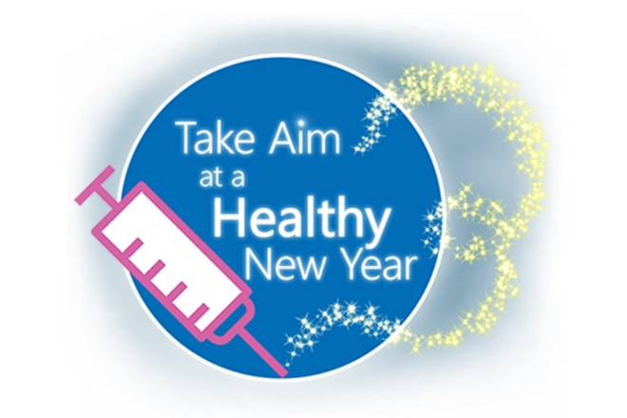
COVID-19 Vaccine
Social Media Messaging

Please consider sharing the following messages via your social media channels such as Facebook, Twitter and Instagram. Right click the “Take Aim” logo above to “Save as Picture” and include it as the image with your posts.

Is it time to get your COVID-19 bivalent booster? It is the best option for protecting yourself and others from #COVID-19. View the 1-minute #COVID Boosters video: https://youtu.be/nclgmqzTzZE #Vaccinated #HealthyNewYear

<Insert Organization Name> encourages everyone to keep up to date with #immunizations. #COVID-19 vaccinations are the best, safest way to protect against severe illness, hospitalization & death. Learn more: https://youtube.com/watch?v=8Ga-2uj0URU #Vaccinated #HealthyNewYear

Is it the flu or COVID? Now’s the time to get vaccinated for both. This flyer explains the differences and similarities: https://hqin.org/resource/flu-or-covid-19-flyer #Vaccinated #HealthyNewYear #COVID #COVID-19

Data continue to show that COVID-19 vaccines are safe and effective. Get vaccinated as soon as you can and get a booster shot when eligible. Find your vaccine: www.vaccines.gov #Vaccinated #HealthyNewYear #COVID #COVID-19
This material was prepared by Health Quality Innovators (HQI), a Quality Innovation Network-Quality Improvement Organization (QIN-QIO) under contract with the Centers for Medicare & Medicaid Services (CMS), an agency of the U.S. Department of Health and Human Services (HHS). Views expressed in this material do not necessarily reflect the official views or policy of CMS or HHS, and any reference to a specific product or entity herein does not constitute endorsement of that product or entity by CMS or HHS. 12SOW/HQI/QIN-QIO-0390-12/21/22

