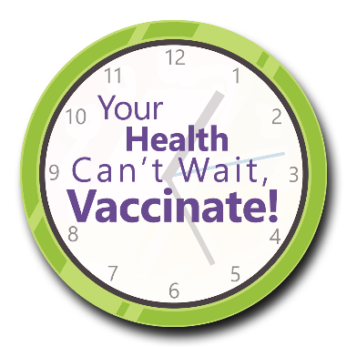
Your Health Can’t Wait, Vaccinate!
Vaccine Encouragement Email Signatures

The following statements can be customized to your organization and added to staff email signatures, newsletters and mailers.
- Vaccines save lives! Yet people all over the world still become seriously ill or even die from diseases that vaccines can help prevent. Take care of yourself and others. Stay up to date on recommended vaccines.

- <Insert Organization Name> encourages everyone to keep up to date with immunizations. Don’t forget that you can take more than one vaccine type at a time and get twice the protection at one visit.

- Vaccines are the best way to protect yourself from certain preventable diseases. Make sure you’re caught up on your vaccinations to protect yourself and avoid spreading illnesses to others. Learn more.

- Are you up to date? Vaccines prevent diseases that can be very serious. All adults need vaccines to help protect themselves and others. Vaccine recommendations are based on age, health condition, job, lifestyle or travel habits.

- Some vaccine-preventable diseases can have serious complications or even lead to later illnesses. Vaccination provides protection not only against the disease itself but also against the dangerous complications or consequences that it can bring. Here’s how.
This material was prepared by Health Quality Innovators (HQI), a Quality Innovation Network-Quality Improvement Organization (QIN-QIO) under contract with the Centers for Medicare & Medicaid Services (CMS), an agency of the U.S. Department of Health and Human Services (HHS). Views expressed in this material do not necessarily reflect the official views or policy of CMS or HHS, and any reference to a specific product or entity herein does not constitute endorsement of that product or entity by CMS or HHS. 12SOW/HQI/QIN-QIO-0545-05/26/23

