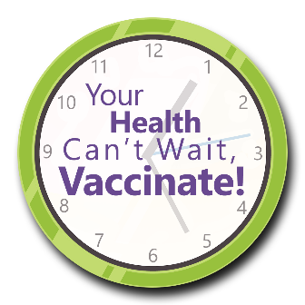
Your Health Can’t Wait, Vaccinate!
Vaccine Letter to Residents and Family Members/Responsible Party

Tips for Using the Letter to Promote Vaccines

The letter on the following page is a template intended to be adapted for use by an administrator, director of nursing, medical director, infection prevention nurse, etc.
Following are some suggestions to help maximize your message:
- Personalizing the letter may provide stronger encouragement for recipients to get a booster vaccine.
- The letter can be used in all settings where vaccines are promoted.
- The template is framed to take a caring approach rather than a statement of enforcement.
- It is recommended that the letter be sent to ALL residents and/or family members to avoid singling out those who remain unvaccinated or who may not be up to date on their vaccinations.
This material was prepared by Health Quality Innovators (HQI), a Quality Innovation Network-Quality Improvement Organization (QIN-QIO) under contract with the Centers for Medicare & Medicaid Services (CMS), an agency of the U.S. Department of Health and Human Services (HHS). Views expressed in this material do not necessarily reflect the official views or policy of CMS or HHS, and any reference to a specific product or entity herein does not constitute endorsement of that product or entity by CMS or HHS. 12SOW/HQI/QIN-QIO-0542-05/25/23
Your Health Can’t Wait, Vaccinate!

Dear (named resident or named family member/responsible party),

We take many safety measures to help keep our residents and staff healthy. Besides cleaning, masking as needed and handwashing, we also encourage those who are due to get vaccines. This is all part of our effort to control COVID-19 and other infections.

Vaccination can help keep everyone in our facility safe. Vaccines can reduce the risk of sickness, hospitalization or death. The more people who take vaccines, the less likely they are to spread illness. For this reason, we are reviewing everyone’s current vaccination status for flu, pneumonia, COVID-19 and shingles.

COVID-19, shingles and the flu are caused by viruses. Pneumonia is caused by bacteria. COVID-19, flu and pneumonia spread through air droplets. Shingles is caused by the same virus as chickenpox. But the good news is that there is a vaccine for all of these illnesses.
At the very least, we recommend that everyone who is able to gets an annual COVID-19 vaccine. It provides the ultimate protection against the COVID-19 virus and long COVID.

Even if a person has had COVID-19, they may get the virus again. Also, they can spread the virus even if they do not have symptoms. Getting the vaccine can decrease how sick someone gets and reduce the likelihood of getting long COVID. It also reduces the chance of death from COVID-19.

If a resident in our care has missed any vital vaccines, we will contact the resident or family member (as appropriate) to help us get their vaccinations up to date. We may also contact a resident or family member for clarification of vaccine status.

If you have questions or concerns, please feel free to email me at _______________________ or schedule a face-to-face conversation by calling _____________ to reserve a date and time.

Sincerely,

