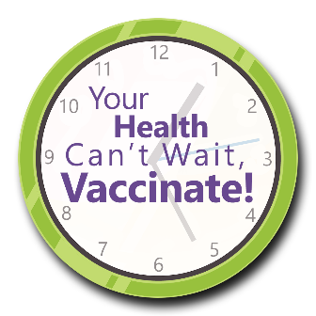
Your Health Can’t Wait, Vaccinate!
Sample Facility Outbreak Memo

Tips for Customizing a Memo to Alert Staff, Patients,
Residents, Participants and Families of a Facility Outbreak

Use the memo template on the following page to craft a facility-specific response (via letter, email, electronic notification on the facility’s website, etc.) to an outbreak or pandemic that impacts facility operation.
Review each section and customize the highlighted content denoted by <left- and right-angled brackets>.
- To: Who the communication is targeting specifically
- From: Facility or administrator’s name
- Date: Communication date
- Re: Briefly describe the outbreak
- Case Numbers: Include positive cases
- Illness: Specify type
- Group Testing Positive: Specify patients, residents, participants, etc.

This material was prepared by Health Quality Innovators (HQI), a Quality Innovation Network-Quality Improvement Organization (QIN-QIO) under contract with the Centers for Medicare & Medicaid Services (CMS), an agency of the U.S. Department of Health and Human Services (HHS). Views expressed in this material do not necessarily reflect the official views or policy of CMS or HHS, and any reference to a specific product or entity herein does not constitute endorsement of that product or entity by CMS or HHS. 12SOW/HQI/QIN-QIO-0658-10/19/23
Your Health Can’t Wait, Vaccinate!

Memo

To: <insert name>
From: <insert facility name>
Date: <insert current date>
Re: Facility Outbreak of <insert type>

As of <MM/DD/YYYY>, we have had a total of <#> positive cases of <COVID-19/influenza/norovirus, etc.> among <residents, participants, patients> in the facility. We have had <#> staff cases, as well as several potential exposures.

Please note, we are maintaining a clean environment and encouraging everyone to frequently and thoroughly wash their hands.

If you are a patient or reside in the facility or visited recently and have symptoms of illness (i.e., fever, cough, nausea, vomiting diarrhea, etc.) please report the symptoms to a staff member. If you are currently experiencing symptoms like those previously described, consider not visiting until symptoms resolve.

We encourage everyone to keep up to date with their immunizations. Keep in mind, you can take more than one vaccine type at a time to get twice the protection with one visit.

Your health can’t wait, vaccinate!

<Insert Organization Name>

For more information, scan the QR codes:

Symptoms of COVID-19 | CDC | The Symptoms of Norovirus | CDC | Protect Yourself from COVID-19, Flu and RSV | CDC | Your Health Can’t Wait, Vaccine! Campaign | HQIN
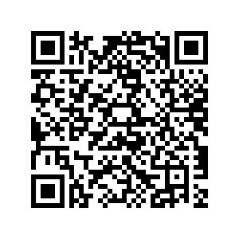 | 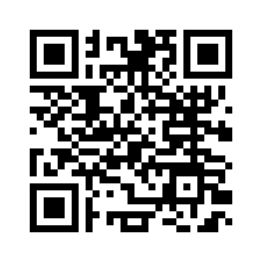 | 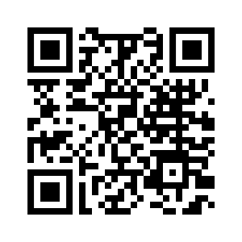 | 